M/S Unique Book Media,
Srinagar.

No: KGP/Estt/2025/629-630 Dated:16-07-2025

Subject: Supply order for Books.

Sir/Madam,
S.No | Name of the Book | Qty Required
1 | Language and Communication Skills-Sharanjeet Kaur | 200
2 | Chemistry and Environmental Science-GH Hugar | 100
3 | Workshop Practice-Swarn Singh | 50
Your Discount rates on Books have been approved by the market Survey committee. You are as such requested to supply the below-mentioned books to this institution within five days from the date of this supply order. The Bill of cost shall be sent in triplicate for pass and payment. The payment shall be made after receipt of the books. The rates shall be inclusive of GST and any other charges. The rates are FOR Kashmir Govt. Polytechnic College Srinagar.

Yours Sincerely
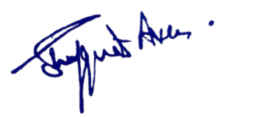

Principal
Kashmir Government Polytechnic College
Srinagar

Copy to the:
- Library Section for information and necessary action.

